# Emails:

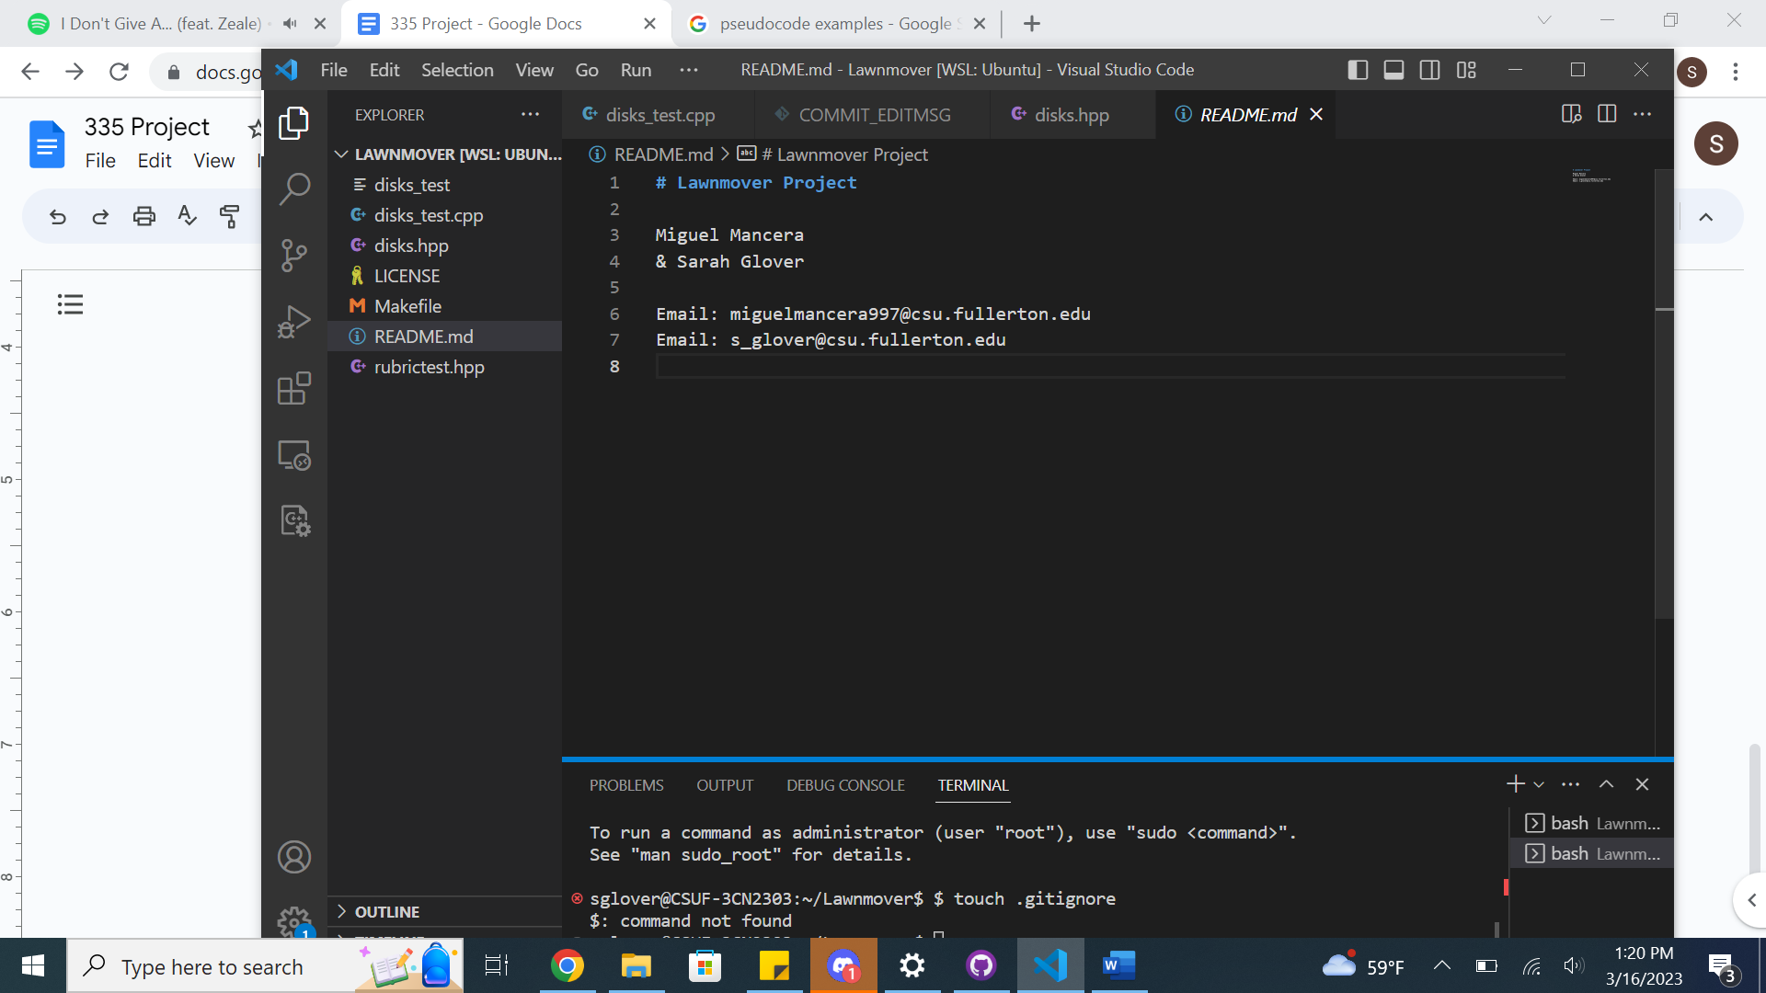

# Algorithms:

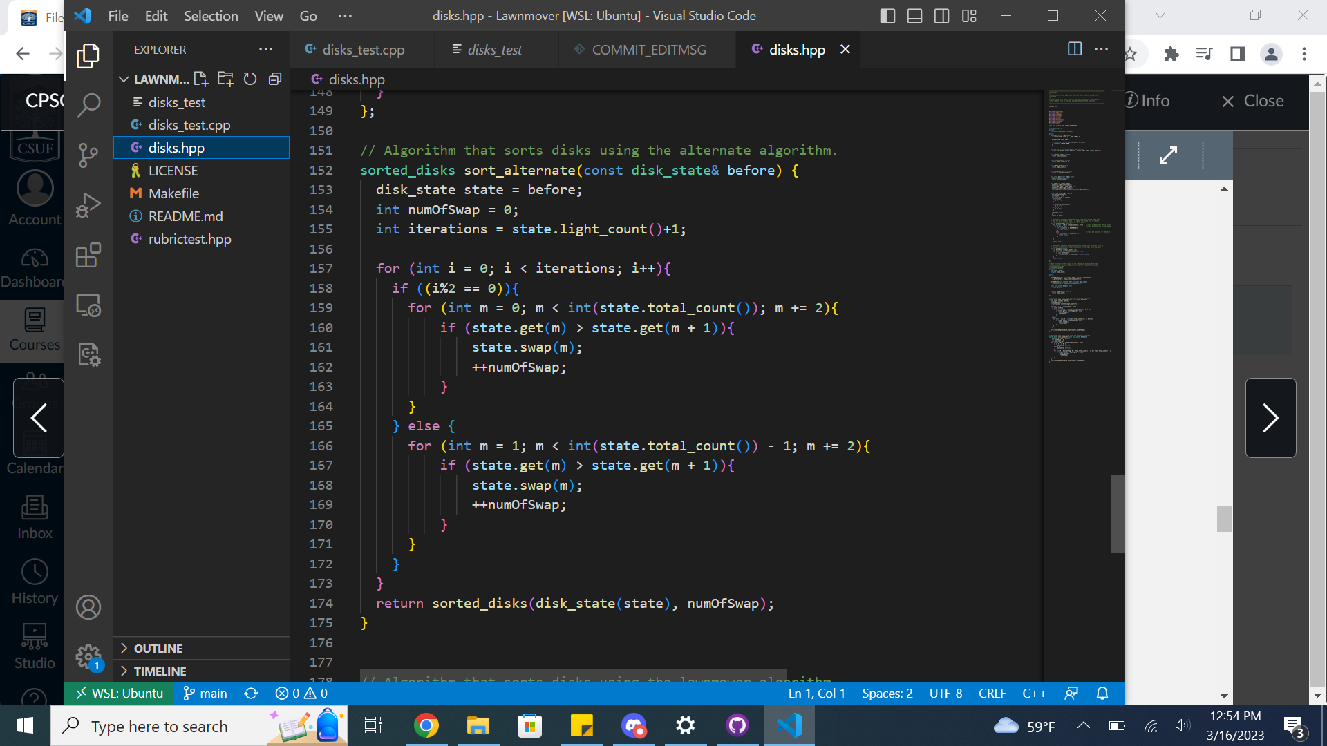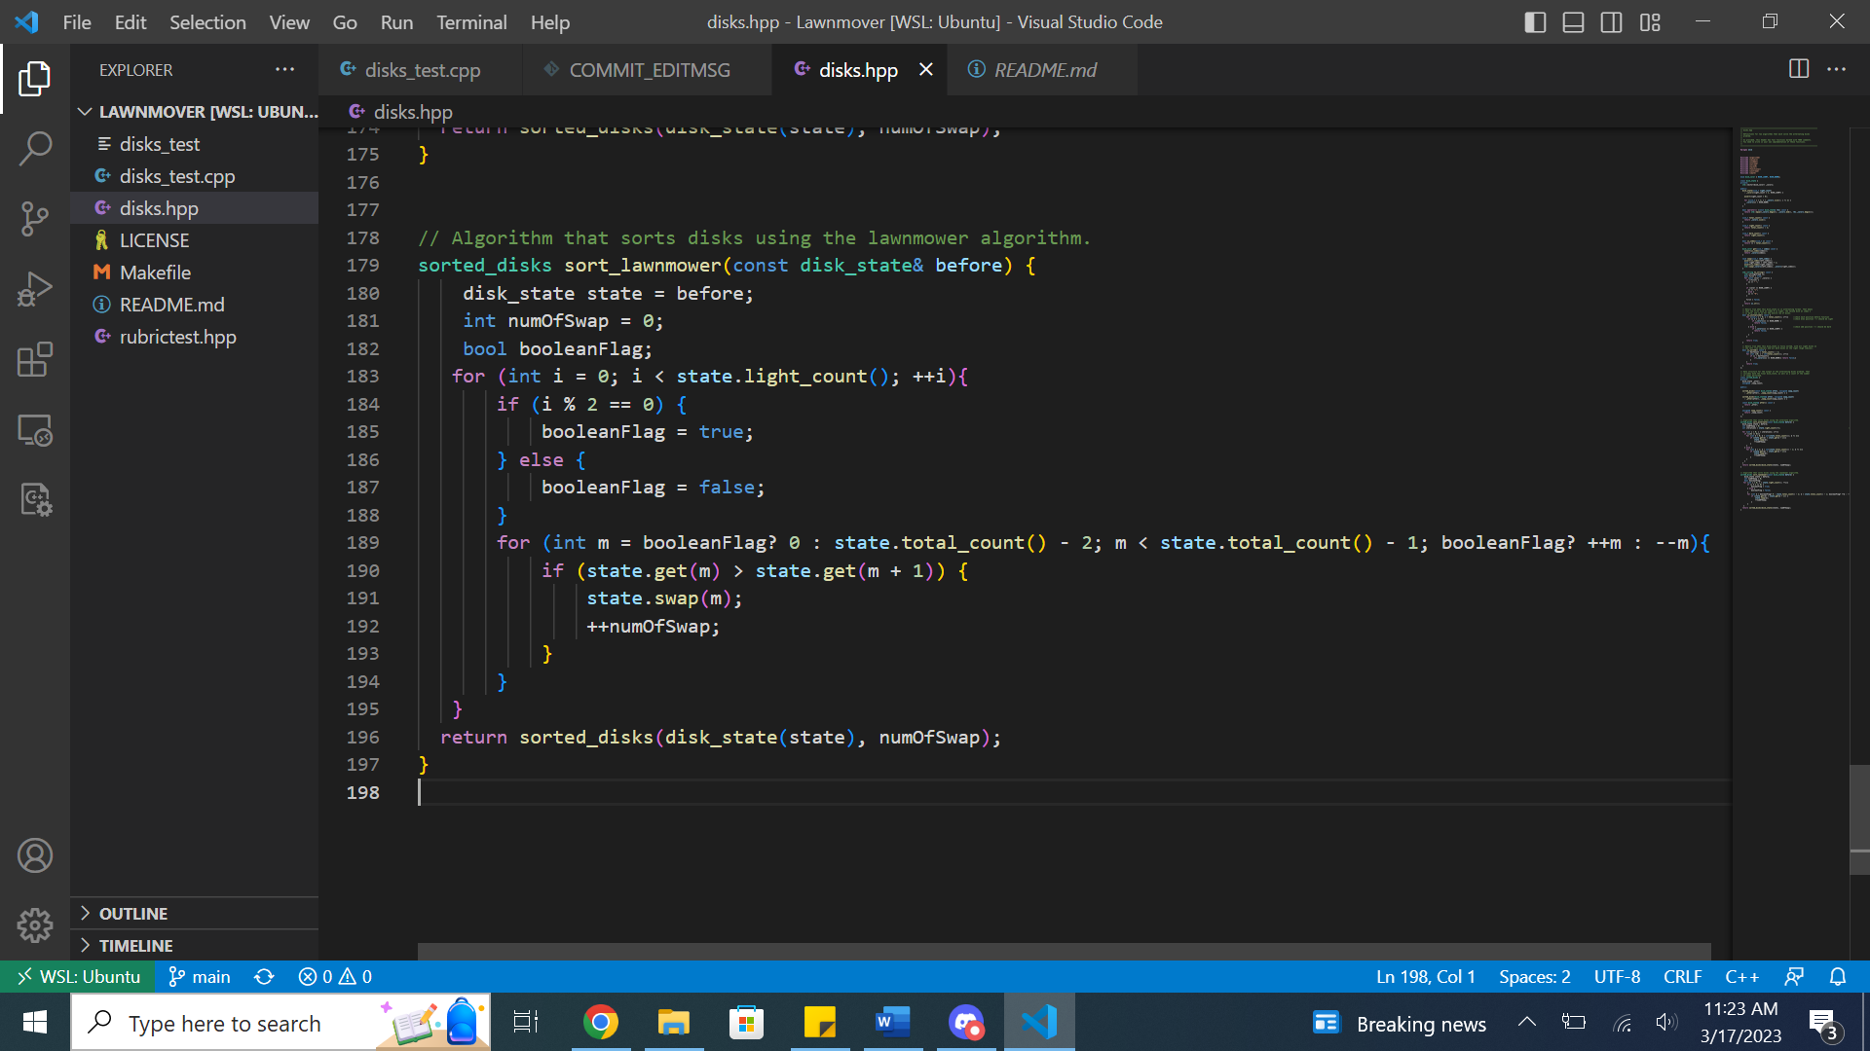

# Execution:

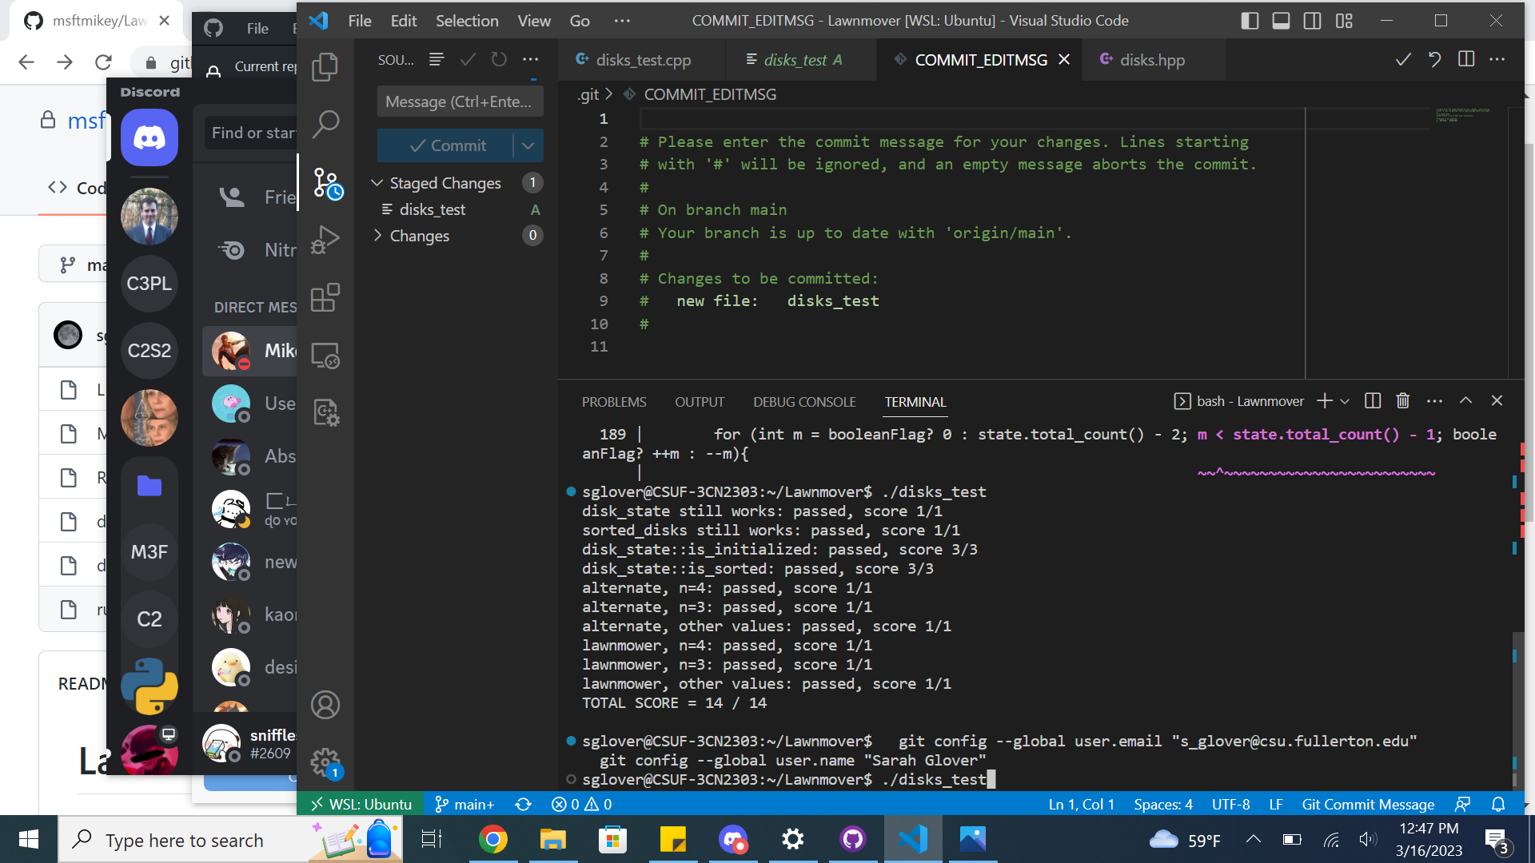

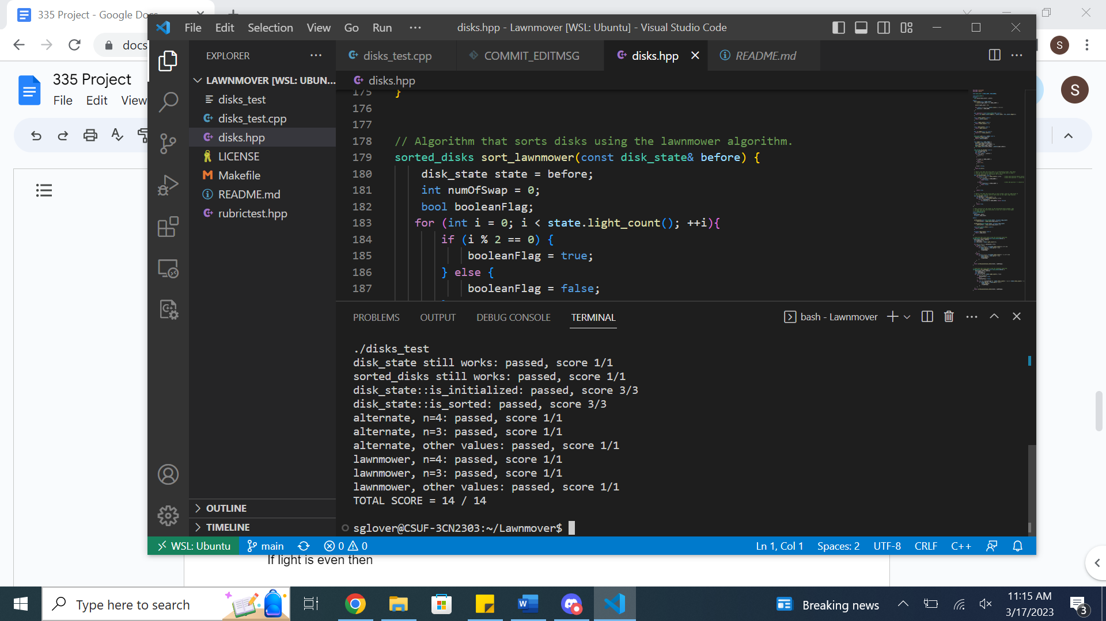

# Pseudocode:

sort_lawnmower

For i - 0 to number_of_iterations-1 do: //Iterations

For j=0 to 2n-1 do //moving left to right

if(list[j] == dark AND list[j+1] == light)

Swap them

End for

For j=2n-1 to j=0 do //moving right to left

if (list[j-1] == dark AND list[j] == light)

Swap them

End for

End for

Sort_alternative

Number_of_iterations = n+1

For i=0 to number_of_iterations-1 do

If i is even do

For j=0 to length(list) -1 step 2 do

If (list[j] == dark AND list[j+1]== light)

Swap them

End for

Else do // if i is odd

For j=1 to length(list)-2 step 2 do

if(list[j] == dark AND list[j+1] == light)

Swap them

End for

End for

# Mathematical Analysis:

**Sort_Alternative**

Step Count & Time Complexity

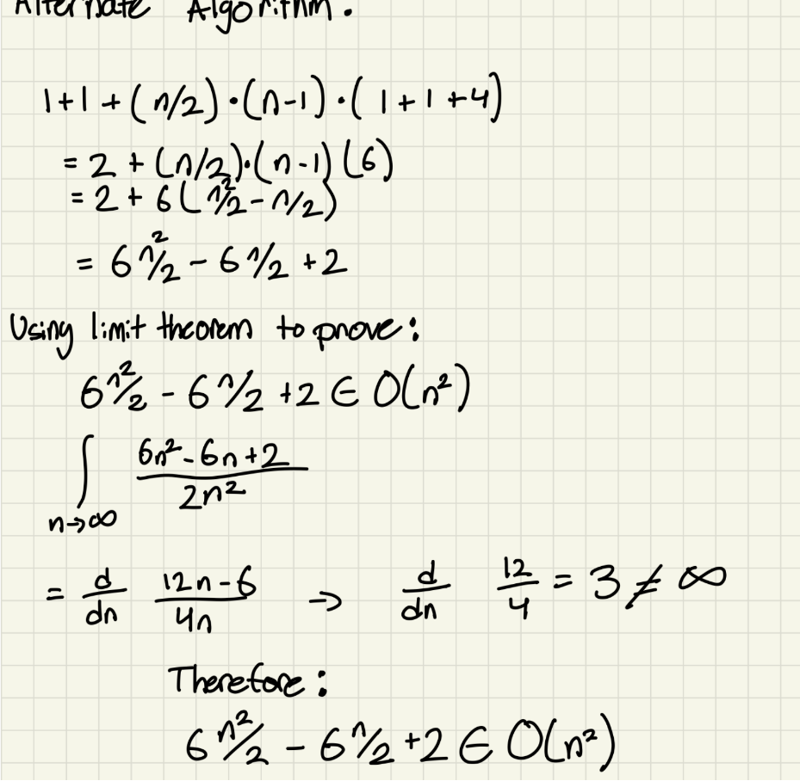

**Sort_Lawnmower**

Step Count:

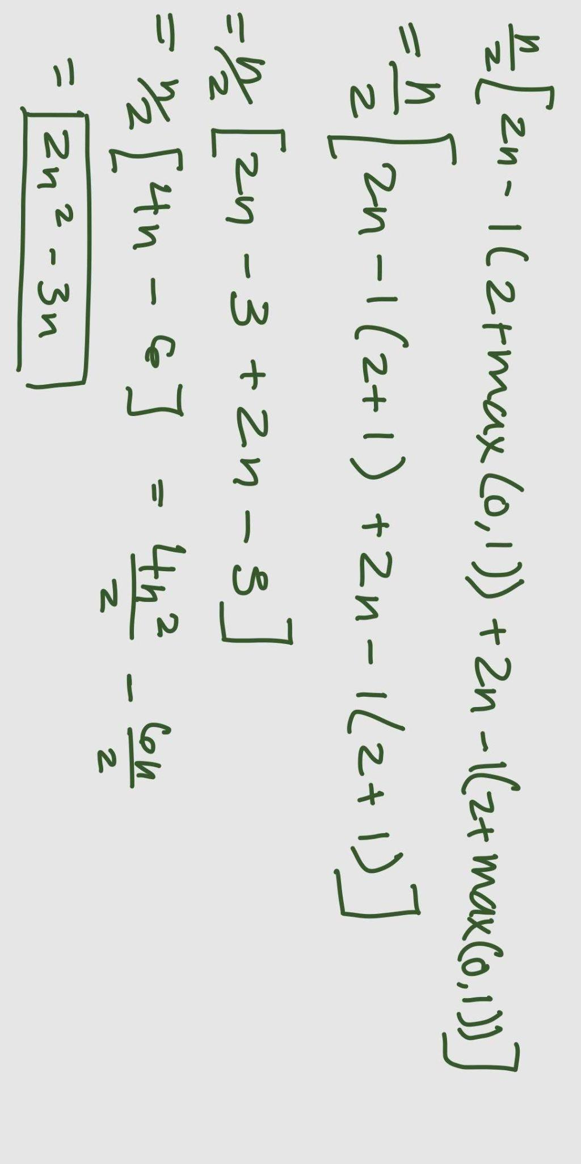

Time Complexity:

